DETAILED REPORT

V-GUARD INDUSTRIES LTD – BIG IDEA TECH DESIGN COMPETITION 2026

Team Name: TI3271_Codey Tingle
Team Member:
1) Ayush Manoj Garg
2) Eshan Shukla
3) Tanay Chaplot

Number of words: 4812 Date of Submission: 28th August’ 2026
Google Drive Link: (For Video and Autocad File):
https://drive.google.com/drive/folders/1Qm1sRybo6V1uuClJ4N6NP5RQUzN4hlHS?usp=sharing

Synopsis
India's residential infrastructure continues to suffer from erratic power supply, and the home inverter with the battery is what enables light, cooling, connectivity, and medical equipment. However, even with today's smart inverters that have Wi-Fi enabled, the devices remain reactive: they provide data about their current state, do not predict failures, do not understand load, nor make decisions on their own. Batteries unexpectedly fail during outages; there are excessive backups on non-essential loads; warranty becomes a source of controversy rather than service.
With V-Guard Sentinel, this problem gets solved: a low-cost, on-device AI Core embedded directly into the inverter will predict the gradual deterioration of the battery weeks in advance as a graded warning (and detect any acute failures), manage charging and critical circuit usage, and detect disturbances in the grid, all while offline, not requiring any access to the internet. The models will improve along with V-Guard's internal fleet data growth – the unique moat of data that is impossible to replicate in the industry, as well as through federated learning for connected units if required.
In this report, we develop the Phase-2 concept into an engineering-grade solution: physics of battery degradation that can be measured and learned from; system and hardware architecture based on galvanic isolation and the proven TinyML silicon; machine learning approach for estimating state of health and remaining useful life of batteries, with an honest evaluation of the lack of lead-acid data and prediction challenges; logic of load management; and learning pipeline. We define the specifications of electrical, computational, model and product parameters, prototype development and validation strategy, relevant Indian and international standards, honest comparison of incremental vs standalone cost, and market, sustainability and business case. Sentinel transforms V-Guard from the company protecting power of India to the intelligence layer that runs Indian homes.

Table of Contents
1. Introduction 4
2. Problem Context and Motivation 4
2.1 India's power-reliability gap 4
2.2 The battery as the silent point of failure 4
2.3 Why degradation is predictable, and why today's products miss it 5
2.4 The cost of the status quo 5
3. Proposed Solution: V-Guard Sentinel 5
4. System Architecture 6
5. Hardware Design of the AI Core 7
5.1 Compute 7
5.2 Sensor front-end isolation 8
5.3 Actuator, power and mechanics 8
5.4 Cost: Incremental vs. stand-alone 9
6. Engine 1: Predictive Battery Health and Remaining Useful Life 9
6.1 Estimation stack 10
6.2 Data strategy and lead-acid mismatch 11
6.3 On-device feasibility 12
6.4 Lead-time in real terms 1
7. Engine 2: Habit-Learning Autopilot and Load Prioritisation 13
8. Engine 3: Energy Coach and Grid Shield 16
9. Engine 4: Federated Fleet Intelligence 17
10. Key Parameters and Performance Targets 18
11. Prototype and Validation Plan 19
12. Standards, Safety and Compliance 19
13. Feasibility and Manufacturing 20
14. Business Value and Market Opportunity 21
15. Sustainability and Social Impact 22
16. Competitive Differentiation 22
17. Risks and Mitigations 22
18. Roadmap and Vision 23
References 24

1. Introduction
How does V-Guard transition from smart products to intelligent products? The core idea is V-Guard Sentinel, which is an intelligent upgrade for the inverter and its battery. Wherever this report specifies a capability or a number differently from the executive summary - such as detection instead of prediction of grid sags, benefits given as a range, cost split into incremental and standalone components - this is just a matter of refinement within the concept for precision, not scope change. The report covers the physics of the problem, the system architecture and hardware, the machine learning methods employed and their limitations, parameters to define, prototype development and validation process, standards and safety, unit economics, and deployment. Through the report there is a clear thread: we draw a line between what is ready to deploy and what is research target, since it is engineers who read the report, and credibility is all that counts.
2. Problem Context and Motivation
2.1 India's power-reliability gap
According to independent surveys, the experience of Indian households is far worse than official averages of electricity availability in feeders. An estimate is that about 85% of households have daily outages and 37% have two to eight hours of outage per day [1]. One third of households suffer any of the blackouts, low-voltage or appliance-damage events in a month [2]. Official figures of about 22.6 hours of rural electricity supply hide the evening crash, when rural supply between 5 and 11 PM is only about 4.7 hours [3]. Voltage level fluctuates widely in households, from 180 V to 270 V against 230 V nominal. For tens of millions of households in India the inverter and battery are essential components rather than a comfort.
2.2 The battery as the silent point of failure
The tubular lead-acid battery is still about half the Indian inverter-battery market, and it is the component that strands the user. Most failures are gradual and detectable: the months-long endpoint of irreversible sulphation from chronic undercharge, positive-grid corrosion, water loss, active-material shedding and acid stratification [4]. Only a few modes, such as a corrosion open-circuit, arrive without warning. Lithium-ion ages by different mechanisms, SEI growth and lithium plating under cold fast charge, but the principle holds: degradation is progressive and observable [5]. Temperature is the dominant stressor in India. Lead-acid life roughly halves per 10 degrees Celsius above 25 [6], so a battery rated ten years at 25 C ages about three times faster at 41 C, and real duty cycles shorten it further. This is exactly the environment V-Guard sells into.
2.3 Why degradation is predictable, and why today's products miss it
Every ageing mechanism leaves electrical fingerprints for an inverter to detect: increase of the internal resistance, worsening of the voltage sag under load, decrease in charge acceptance and coulombic efficiency, and shifts in the open-circuit-voltage curve of the rested battery. Internal resistance is the main health metric that can be measured online, and charge acceptance decrease is a cheap yet informative lead-acid battery health indicator [4][6]. No single electrical signature defines a failure mode, but their combination provides good estimate of battery health (see Exhibit 5). Currently available inverters, including Wi-Fi models, measure at best current health status of the system; none of them provides predictive insights. There are four gaps to fill: foresight of the failure, load intelligence during outage, energy intelligence as time-of-use pricing becomes more common, and proactive rather than reactive maintenance. V-Guard, founded in 1977 in order to solve the very problems of unreliable power supply in India, manufactures its own batteries, invested 30.35% stake in battery technology firm, and opened a 120-crore innovation campus in Kochi [25].
2.4 The cost of the status quo
The current state of affairs is costly for a household: an early battery failure means additional expense for replacement and direct cost for V-Guard within flat warranty period; an outage, which lasts longer due to poor battery management, causes spoilage and disruption in work, study and medical routines; voltage excursions reduce lifespan of all appliances. Because the current inverters do not transform the data they measure into foresight of failure, this cost goes unseen and unsaved. Intelligence, implemented directly in the product itself rather than as an extra application, saves sunk cost and avoids future expenses.
3. Proposed Solution: V-Guard Sentinel
Sentinel is an intelligence layer, not a new gadget. A compact AI Core, a microcontroller with a small sensor set, is embedded in new inverters and offered as a retrofit module for the installed base. It runs four on-device engines (Exhibit 1). Engine 1, Predictive Health and Longevity, estimates true state-of-health, predicts a remaining-useful-life window, flags degrading internals early, and applies an adaptive charge-and-thermal policy; a signed, append-only, device-key-authenticated health log turns warranty into a one-tap, data-backed process. Engine 2, the Habit-Learning Autopilot, learns the home's load and outage patterns and keeps only critical loads alive during a blackout. Engine 3, Energy Coach and Grid Shield, shows where power goes and detects grid disturbances to protect appliances. Engine 4, Fleet Intelligence, sharpens the shared models as V-Guard's proprietary fleet data grows, centrally, with optional federated learning for connected units. The same compute platform, with product-specific sensors and models, extends across pumps, stabilisers and water heaters.

4. System Architecture
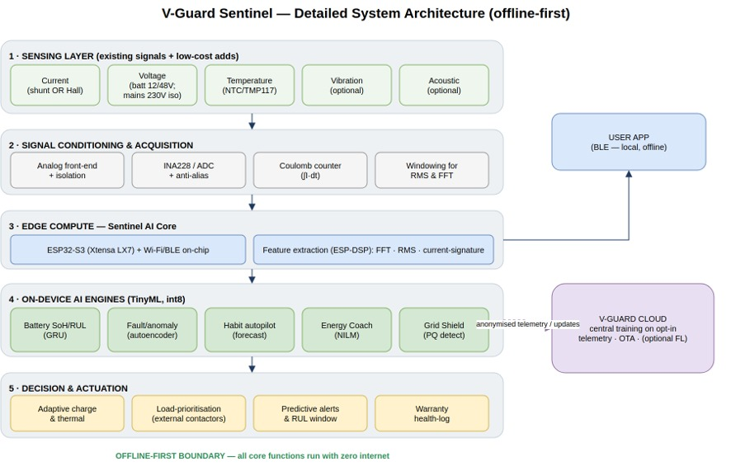
Exhibit 1. Detailed architecture of V-Guard Sentinel: the sensors of existing inverters feed on-device TinyML engines that run autonomous control actions; only anonymized telemetry and model updates get outside of the home, while all core functions run offline.
Sentinel is arranged as five on-device layers within the offline-first boundary, with opportunistic links to a phone app via Bluetooth Low Energy and to the V-Guard cloud via Wi-Fi. The sensing layer includes the current (via external shunt or Hall sensor), isolated voltage and temperature, with optional vibration/acoustic sensing for detecting faults on the inverter side. The signal-conditioning layer provides the analog front-end, galvanic isolation, high resolution ADC, anti-alias filters, coulomb counter and windowed buffers for FFT and statistical analysis. Edge Compute layer is the AI Core itself. AI Engine layer is occupied by the quantized TinyML models, and Decision & Actuation layer runs adaptive charging, relay-based load prioritization, alerting and health logging. Every core function runs without any connection to the Internet; the cloud is optional for federated aggregation, OTA updates and analytics. This structure of the layers – sensing, conditioning, compute, inference, and action – is similar to that of conventional embedded control stacks, keeping the design conventional to manufacture while moving the intelligence to software.
5. Hardware Design of the AI Core
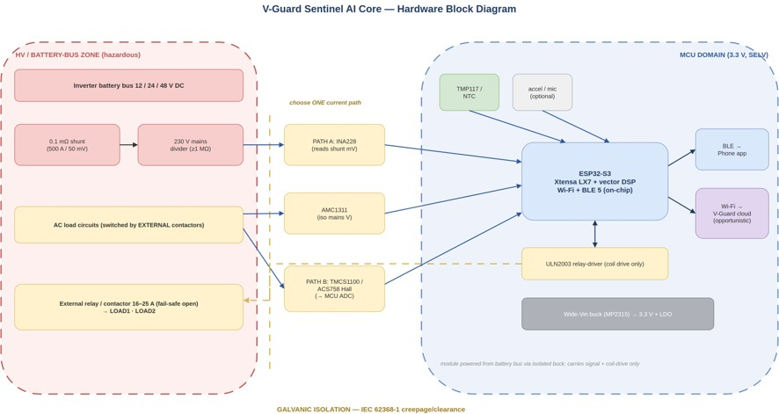
Exhibit 2. Block diagram of AI Core hardware: the galvanic-isolation barrier isolates the hazardous battery-bus/HV zone from the SELV MCU domain; isolation ICs (INA228, AMC1311, TMCS1100) connect both sides safely.
5.1 Compute
Workloads – a small recurrent or 1D convolutional network for RUL, an autoencoder for anomaly detection, power quality analysis using FFT and light load monitoring – nicely fit into the budget of tens of kilobytes at int8 precision. Cost-optimal choice is the Espressif ESP32-S3: dual vector-capable cores with integrated Wi-Fi and Bluetooth Low Energy on one chip worth of about 300 rupees; this removes a need for a separate radio, thus saving 200-400 rupees on BOM [30]. The same architecture can be dropped onto a higher tier MCU, if in some future variant the additional compute is needed; without other changes. Feature extraction uses Espressif ESP-DSP library, where a 1024-point fixed-point FFT takes about one millisecond on LX7 vector core [12]. Event detection (sag/swell) is performed using one cycle time-domain RMS; multi-cycle FFT is reserved for harmonics analysis, so these run at different windows.
5.2 Isolated sensing front-end
Safety is the cornerstone of the design. The battery bus is low-voltage DC (12/24/48 V); anything touching the AC mains, observed between 150 and 300 V, is galvanically isolated from the microcontroller domain, and the 50-to-150-ampere battery current never passes through the module's PCB. Following the architecture of every commercial battery monitor, a high-current shunt or Hall sensor feeding a signal-only electronics head, as in the Victron SmartShunt whose 69 x 69 x 31 mm head is essentially our enclosure [32], the Core reads current only as a signal by one of two mutually exclusive routes: a high-current shunt, either the inverter's existing one or an external 500 A / 50 mV (0.1 milliohm) busbar shunt, read by a 20-bit charge-accumulating monitor (INA228, with the 16-bit INA226 as the cost option) that sees only tens of millivolts; or a contactless ACS758/TMCS1100 Hall sensor feeding the MCU ADC directly [30]. An ordinary split-core current transformer will not work, since transformers sense only alternating current. Bus voltage is sensed through a high-value divider into a reinforced isolation amplifier (AMC1311) via thin leads fused at one ampere at the terminal. Temperature uses a battery-terminal NTC with an optional 0.1 degree digital sensor (TMP117). Battery health needs no vibration or acoustic sensing; an optional accelerometer or MEMS microphone appears only in the industrial variant for inverter fault detection. The binding constraint on coulomb counting is current-sense offset rather than ADC resolution, so the design relies on the INA228's built-in offset cancellation and anchors state-of-charge to open-circuit voltage during float-rest intervals between outages.
5.3 Actuation, power and mechanical
Load shedding drives external electromechanical relays or contactors rated 16 to 25 A, chosen for low cost and a fail-safe galvanic open, through a ULN2003 array and isolated coils; solid-state relays are reserved for fast, frequent switching. A wide-input synchronous buck (MP2315 class) taps the inverter's existing rail for a 3.3 V supply at microamp quiescent draw, so the module never meaningfully loads the battery. The package is a UL94 V-0 flame-retardant PC/ABS enclosure of roughly 90 x 70 x 35 mm, the extra height giving relay and connector clearance, housing an 80 x 60 mm PCB with four M3 mounts, IP20, DIN-rail or adhesive mounting, and segregated screw terminals carrying only signal and relay-drive lines plus JST connectors for low-voltage leads (Exhibit 3). It mounts on or beside the inverter, which has ample room in its 275 x 250 x 120 mm envelope, and never on the 40-to-65-kilogram floor-standing battery.
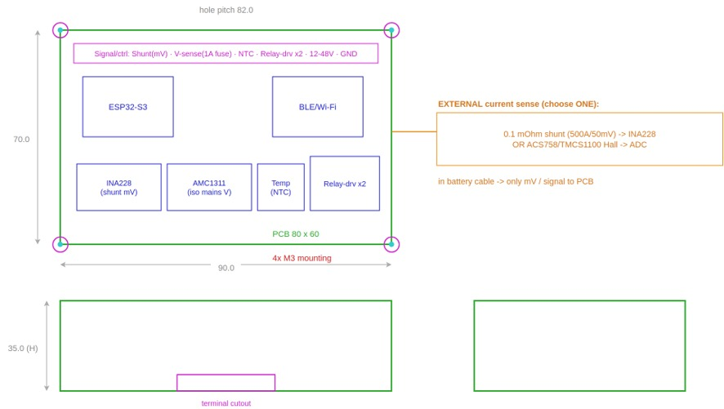
Exhibit 3. Sentinel AI Core – early dimensioned concept design (side/top/front views). AutoCAD editable source files (DXF, parametric AutoLISP) can be found in the CAD directory.
5.4 Cost: the incremental-versus-standalone reality
The itemized bill of material (Exhibit 15) indicates that the basic board costs around 500 rupees, or 800 rupees per standalone unit including an external current shunt if the inverter does not have one. The deluxe board that has high precision isolated current sensors and a current higher contactor stage is about twice to thrice of this amount. An incremental cost of 150 to 800 rupees is feasible in the case of an inverter which already has a shunt, relay circuitry, microcontroller, and power rails - as it happens in metering compatible inverters - since all the components will be shared. It was a deliberate choice to state the cost in this way.
6. Engine 1: Predictive Battery Health and Remaining Useful Life
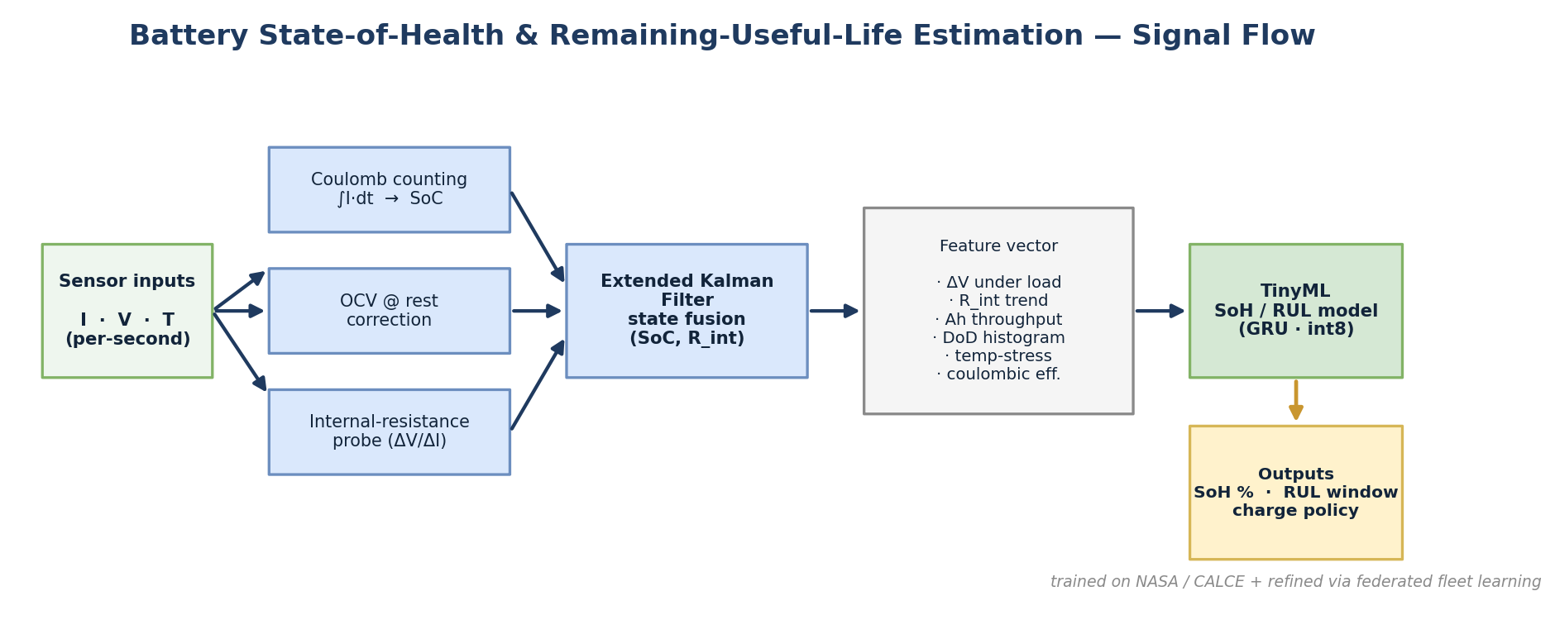
Exhibit 4. Signal flow for Battery SoH/RUL: Coulomb counting, OCV correction, and internal resistance probes are combined using an Extended Kalman Filter to form a feature vector that is then ingested by a TinyML model.
6.1 Estimation stack
Sentinel combines classical estimation with a tiny learned correction factor. Coulomb counting integrates current for a quick state-of-charge but drifts because it integrates sensor bias in an open loop fashion; even a 0.5% current bias could create multiple percent of error per week. Rested open-circuit voltage and an internal resistance measurement - derived from the delta-V/delta-I of natural transient conditions (or cooperative pulse from the host charger), normalised to account for temperature and state-of-charge - correct this, and an Extended Kalman Filter estimates their combination to produce a bounded state, a method well established in commercial BMSs and achieves about 1% state-of-charge RMSE [8][9] (Exhibit 6). The sloping open-circuit voltage curve in lead-acid facilitates this calibration, while flat plateau voltage makes it difficult in lithium-iron-phosphate; this is a design trade-off. A feature vector - voltage sag under load, internal resistance trend, ampere hour throughput, depth of discharge distribution, temperature stress and coulombic efficiency, and incremental capacity peaks obtained in the partial charge sequence following each outage - provides input to a compact quantised model which maps the history of features to a state of health estimate and RUL interval.
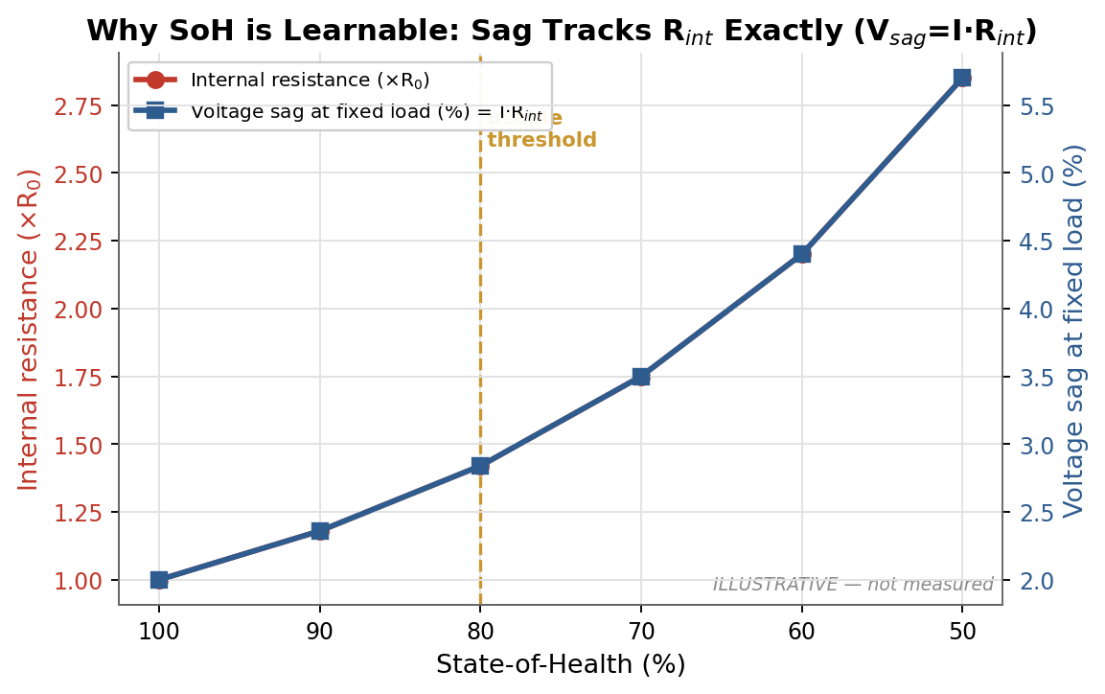
Exhibit 5. The reason why state of health is learnable: internal resistance and voltage-sag-under-load are both measurable indicators of degradation as capacity falls below the 80% usable threshold.
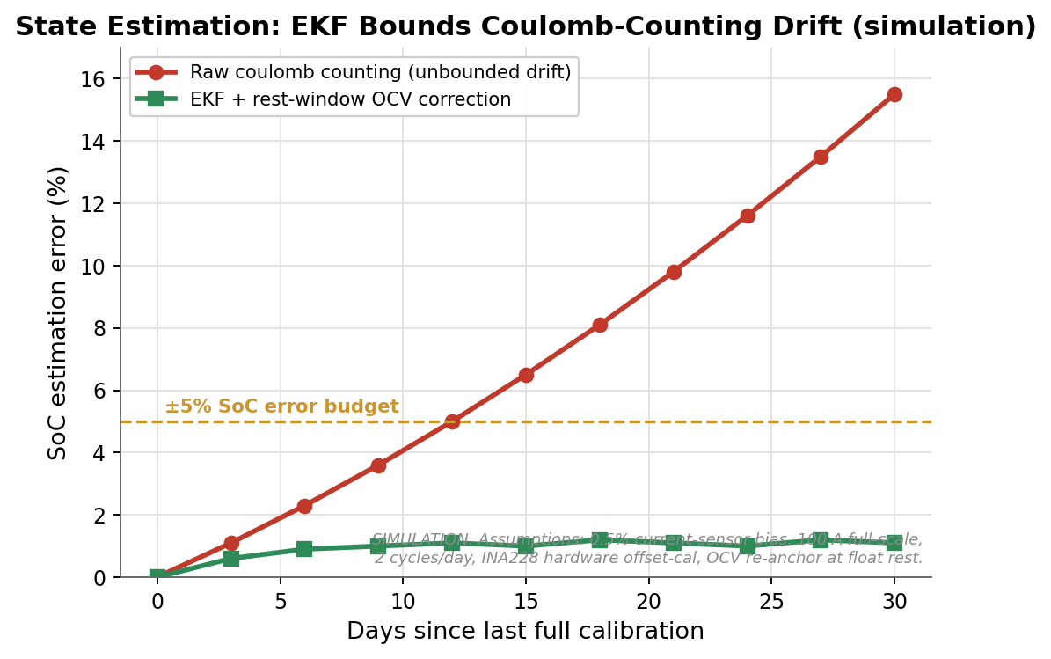
Exhibit 6. State estimation: an Extended Kalman Filter keeps the open-loop error of raw coulomb counting in a +/-5% state-of-charge interval through fusing open-circuit voltage and internal resistance corrections.
6.2 Data strategy and the lead-acid gap
We are clear about the limitation: rigorous and benchmarked machine learning results for the estimation of battery health are all on lithium-ion cells tested in labs, using public datasets like NASA's Prognostics Center of Excellence, CALCE, Oxford and Sandia [7][8][9][10], and there is basically no canonical lead-acid degradation dataset. Therefore, for our tubular-battery product we will conduct an aging campaign ourselves, logging the partial charge curve, DC internal resistance, charge acceptance, temperature, throughput and depth-of-discharge distribution, while using the wealth of lithium-ion data for architecture exploration and transfer learning rather than directly re-using parameters. V-Guard's battery manufacturing and reliability lab facilities make this aging campaign possible in a way that the proprietary data cannot be acquired easily, and thus this aging campaign itself is a defensible moat: the data doesn't exist to be purchased.
The campaign is a concrete programme, not a hope: a representative matrix of tubular cells cycled across the temperature, depth-of-discharge and charge-rate combinations typical of Indian use, instrumented until each reaches the 80% end-of-life threshold, with the resulting proprietary dataset continuously enriched by fleet feedback.
6.3 On-device feasibility
Inference at the microcontroller level is easily achievable as well: TensorFlow Lite Micro requires tens of kilobytes [11], and an existing battery RUL model works with two-millisecond inference in 11 kilobytes of flash and 1.2 kilobytes of RAM on a sub-dollar Cortex-M0+ processor [13], while the vendor-specific ESP-NN kernels offer several-fold further speed and energy advantages on the LX7 vector core [12]. With the health update done once per recharge or hour at most, latency is not an issue at all; the bottlenecks are sensing quality and training data, not compute. State-of-health accuracy has been reported at about one-to-two percent for pristine lithium-ion batteries and around five percent on-device post-quantisation, and coarser for data-starved lead-acid ones - numbers we cite as ranges rather than marketing guarantees.
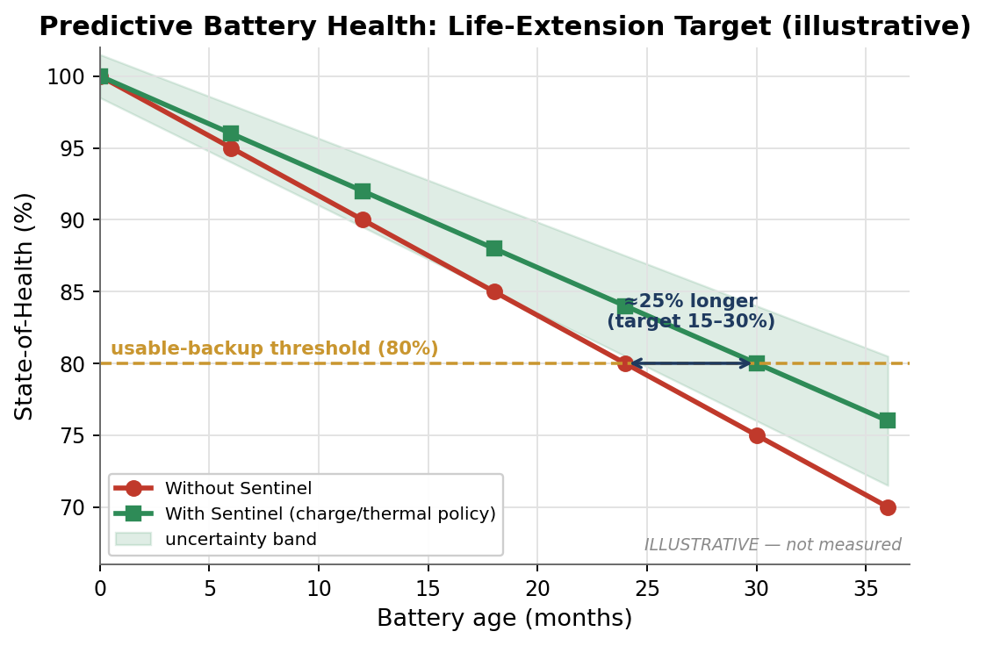
Exhibit 7. Battery health prognosis: Sentinel's charge and thermal policy maintains state-of-health over the usable threshold for longer, and forecasts the replacement point weeks ahead.
6.4 Honest lead-time framing
The best published results, with lithium-iron-phosphate batteries, have been able to predict total cycle life starting from the hundredth cycle at nine percent error [7]. However, three fundamental limitations should be stated explicitly. The capacity fade 'knee' is a physical limitation, and nominally identical batteries vary greatly in behaviour. The RUL is path-dependent on future load profile, which is impossible to know in advance, thus the Indian inverter duty profile will be less uniform than the lab. In addition, some fault conditions like short-circuits, open circuits due to corrosion and thermal runaway are triggered by specific events and thus are not predictable using voltage, current and temperature alone. Therefore, Sentinel warns of the battery degradation trend instead of predicting failures: it forecasts state-of-health with an uncertainty range, gives a graded early warning - healthy, degrading, or needs replacement in N weeks - months ahead for slow battery degradation and anomaly detection flags for fast ones. This is a feature, as a prediction interval the installer can rely on is better than a precision estimate that will discredit the product on its first miss.
7. Engine 2: Habit-Learning Autopilot and Load Prioritisation
Load prioritisation technology is mature, but interestingly, all commercially available systems use rules-based algorithms on state-of-charge, voltage or frequency thresholds: fully learned, reinforcement-driven load management system is only a research concept with inflated numbers, and does not exist in Indian home inverters [31]. Thus Sentinel uses a defensible hybrid: rules-based tiers augmented with a learned demand and outage duration predictor. Firstly, it is a universal algorithm and does not require any rewiring: it pre-charges the battery before the outage, controls charging in order to preserve battery health and makes the single essential circuit backup tier - lighting, fan and usually a refrigerator - work, alerting the user and prioritising inside it depending on the state of the charge. A disclaimer we openly make here: in the majority of Indian households the air conditioner and water heater are not connected to the inverter anyway, and thus there is nothing to shed on those tiers. However, in the cases where a house connects non-essential circuits to the inverter - either in the case of bigger systems or in the case of more recent inverters where V-Guard implements a multi-tiered output - the same logic sheds and defers load using external contactors: keep (refrigerator, lights, Wi-Fi, medical devices), defer (water heater, water pump), shed (air conditioner), re-evaluate until the mains power comes back and charge optimally (Exhibit 8). With such non-essential load available, this increases the backup time for essential circuits by the order of ten to twenty percent - again, a conditional benefit, not a universal one, and surely not the sixty percent reported in simulation-only papers. Fail-safe defaults ensure that a sensor or model failure does not cut off critical load.
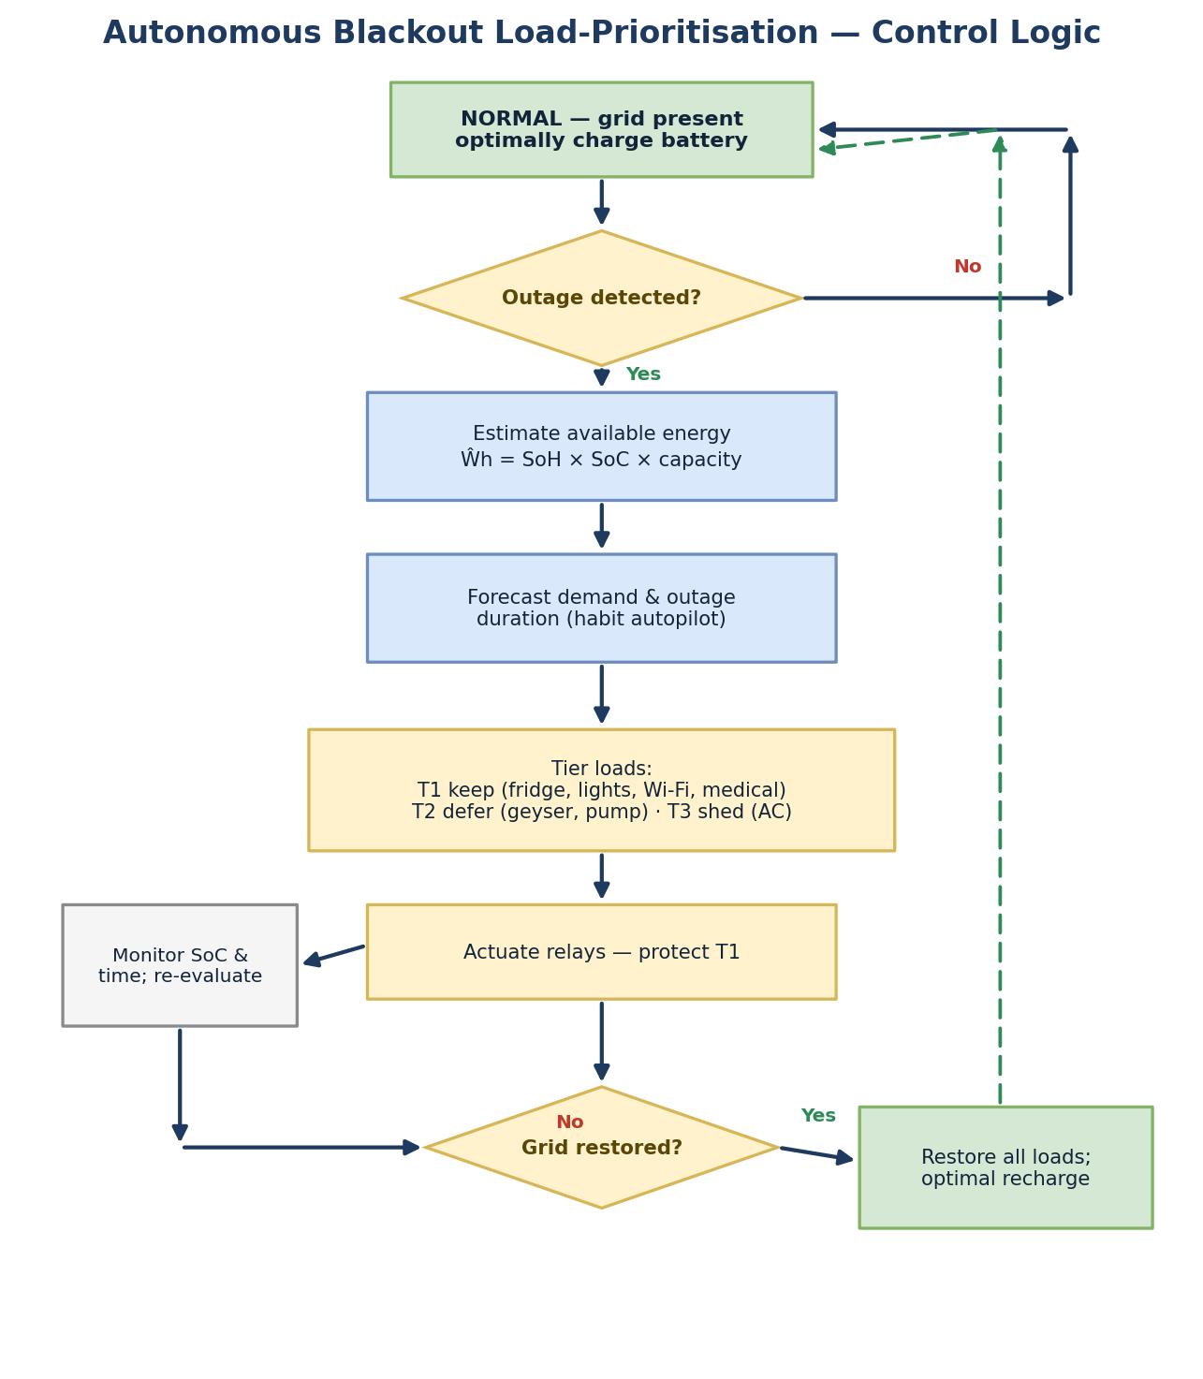
Exhibit 8. Autonomous blackout load prioritisation logic: a rules-based tiers controller informed by a learned demand and outage duration predictor.
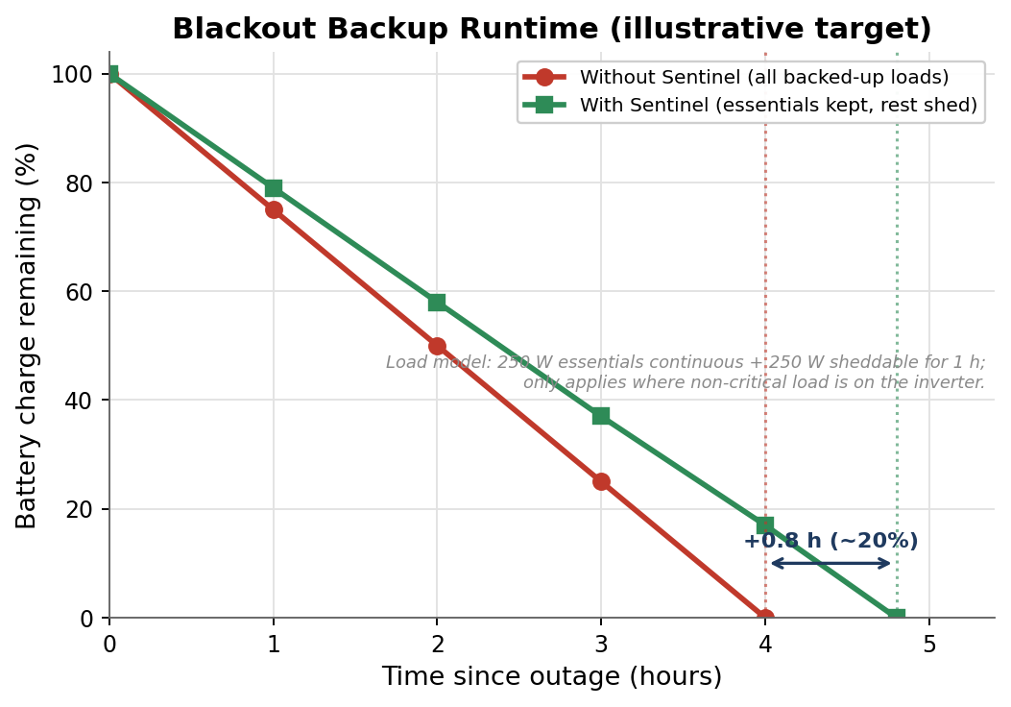
Exhibit 9. Blackout backup runtime (illustrative target, pre-validation): where non-essential loads are present on the inverter, protecting the essentials and shedding everything else increases useful backup runtime of the essentials during the blackout.
8. Engine 3: Energy Coach and Grid Shield
The Energy Coach relies on non-intrusive load monitoring (NILM) techniques to disaggregate energy consumption from a low-frequency (<=1Hz) current signal. The scope of the technology is honest: low-frequency disaggregation accurately separates high power loads such as air-conditioners, geysers, pumps and fridges with a precision of approximately 0.65 to 0.89 F-score on benchmark datasets [20], yet low-power loads and overlapping appliances are well-known limitations, and there is a single publicly available dataset from India (Delhi) [21]. Sentinel is therefore positioning the Coach as providing directional insights with per-home calibration of the loads for the headlines only, viewing fine-grained disaggregation as a roadmap cloud-assisted feature - very valuable with time-of-use tariff adoption following smart meter roll-out nationally [29], but not over-stating its capabilities. Grid Shield is being scoped with the same honesty. Voltage sag is propagated through the grid instantly and does not have a locally observable precursor; hence, the honest capability here is fast detection, not prediction: based on a one-cycle time-domain RMS value, the Core detects the sag in less than one cycle (multi-cycle FFT handles harmonics). The Core itself cannot react faster than the inverter's internal transfer switch, so the role of Grid Shield is logging the event, informing the user and reporting grid abuse to inform protection of the appliances - not an independent tripping capability - aiming for a IEC 61000-4-30 Class-S-level measurement, not a certified Class-A measurement instrument [18][19]. Only a self-caused motor start can be genuinely anticipated; risk assessment in a seasonal and statistical manner is advisory at best. Honesty in claiming detection and not prediction is precisely what an expert judge would award.
9. Engine 4: Federated Fleet Intelligence
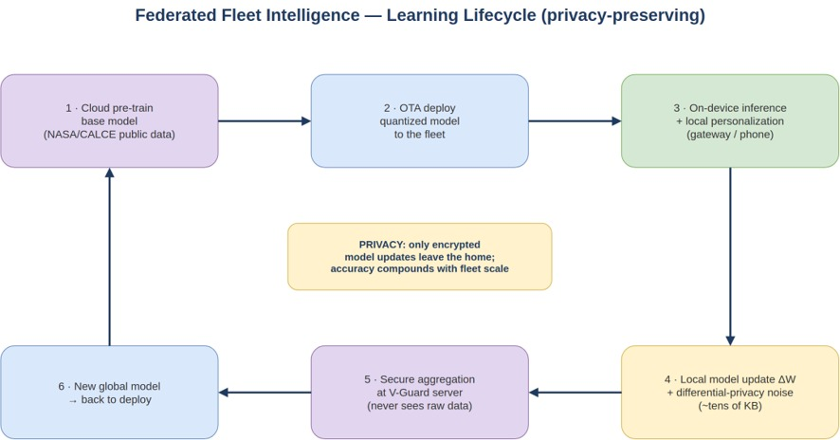
Exhibit 10. Federated learning lifecycle: cloud pre-training, OTA deployment, on-device inference with home gateway/phone-level local training, differential privacy updates, and server-side secure aggregation.
The moat is the data, not the mechanism. V-Guard owns the installed base and manufactures the batteries, so its proprietary aging and field data is the uncopyable asset, and the learning path can stay simple and robust: units log anonymous battery telemetry (voltage, current, temperature, throughput, depth-of-discharge histograms, none of it personally identifiable) and upload opportunistically when power and connectivity allow, V-Guard trains improved models centrally, and pushes them over the air. Inference on the microcontroller runs offline; only learning needs connectivity.
Connected units may additionally opt into privacy-preserving federated learning for edge personalisation. Training deep models directly on the microcontroller across a fleet is not realistic today; at most, sparse on-device fine-tuning is feasible [17]. So the gateway or the owner's paired phone performs the local training round, having the memory, floating-point unit and reliable power; only model deltas of tens to hundreds of kilobytes are uploaded, roughly once a day, and a V-Guard server aggregates them with FedAvg or DP-FTRL. We use Flower, built for exactly this intermittent, framework-agnostic deployment [14]. Because updates can leak training data through gradient inversion, Sentinel combines Secure Aggregation, so the server sees only the summed update [15], with Differential Privacy at a target budget of about epsilon=4, delta=1e-5 per user-year via DP-FTRL, the technique behind large-scale federated keyboards [16]. We are upfront that this path needs a second capable device with connectivity, which most of the rural base does not have, and that privacy strengthens with cohort size, which is why it is an enhancement on the central path rather than a requirement for the product (Exhibit 11).
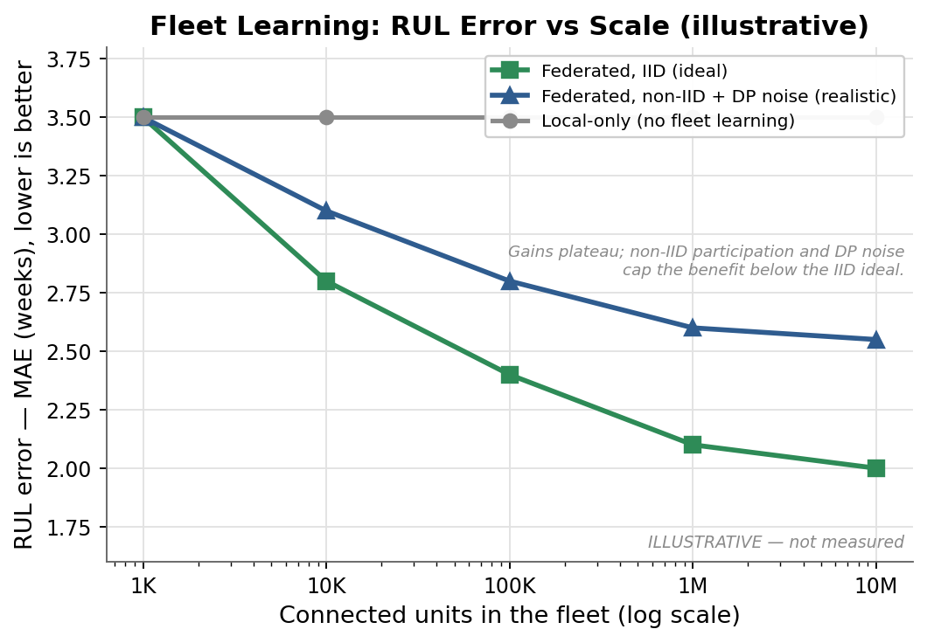
Exhibit 11. The data moat: model accuracy compounds as V-Guard's proprietary fleet data grows with the installed base - via central training, with optional federated learning - an advantage competitors cannot buy.
10. Key Parameters and Performance Targets
That design is parameterised in Exhibit 14, ranging from electrical sensing through to computation, machine-learning thresholds, the federated algorithm, product specifications and environmental conditions. These are the parameters against which the Phase-4 prototype and module are tested to establish acceptability criteria.
11. Prototype and Validation Plan
Capitalising on our team's experience with machine learning and full-stack computing, we will develop a battery-RUL model using NASA and CALCE lithium-ion batteries with augmented synthetic duty cycles for Indian tubulars - showcasing the method and the transfer-learning paradigm used by the in-house lead-acid aging campaign. We will train the model, test the mean-absolute error, root-mean-square error and calibration of the predicted failure window. In addition, we will simulate federated learning on that model using at least five simulated homes in Flower; that will demonstrate that the shared model can learn with no raw data escaping the clients, with Secure Aggregation and Differential Privacy enabled. Our dashboard application will display state-of-health, RUL countdown, the autonomous load-prioritisation simulation and energy intelligence. Optionally, we will develop on-device inference of the quantised RUL model using an ESP32-S3 and a current-sensing breadboard - showing true on-device inference without any custom PCB or manufacture. The CAD files of that module are provided with this submission (DXF, AutoLISP and script). The success criteria include RUL-window hit rate, state-of-charge error within five percent, load-shedding correctness, accuracy of federated learning compared to the baseline of centralised learning, and on-device latency and footprint. Prototype pictures and videos will be made available through the following linked Google Drive folder: [insert Google Drive link].
Each demonstration satisfies a particular marked criterion: training and testing the RUL model satisfies novelty and technology; simulating federated learning satisfies the privacy design; and performing on-device inference with the bill of materials and CAD satisfies feasibility. We will make public the training method and testing data to enable validation of the results by third parties.
12. Standards, Safety and Compliance
The Indian mandatory gate for the electronics is BIS certification to IS/IEC 62368-1, the replacement of IS 13252 Part 1 for ICT equipment [22]; the host inverter stays under IEC 62040 for UPS [23], and our module should not compromise the compliance of the host. Electromagnetic Compatibility and Immunity will follow the IEC 61000 series, including electrostatic-discharge testing, radiated-immunity testing and surge testing; power-quality measurement will be done to IEC 61000-4-30 Class-S-like level [18]. Lithium batteries in our module will comply with IS 16046-2 and IEC 62133-2 [24]. RoHS compliance is required, and CE marking under the Low-Voltage and EMC directives, for export. Isolation in all mains-referenced sensing and sufficient creepage and clearance for 300 volts plus transients, fusing of sense taps, transient suppression on the high-voltage node, and fail-safe relay defaults are the key safety requirements. Whether Sentinel comes as an embedded sub-assembly (under IEC 62040 of the host) or a standalone accessory (its own IS/IEC 62368-1) decides the specific route of compliance.
13. Feasibility and Manufacturing
Sentinel is a software-led upgrade to products V-Guard already builds at scale, so the path to revenue is short: new inverters carry the Core on the main board, and the installed base is addressed by the retrofit module. In-house battery manufacturing lets health models be co-designed with the cell chemistry, which a third-party add-on cannot match, and the Kochi reliability lab provides the aging-campaign infrastructure. Because the compute, sensing and machine-learning blocks are all commercially proven, the risk is integration and data, not invention. Physically the module is a signal-and-control board mounting on or beside the inverter and sensing the battery through an external shunt or Hall sensor, so the 50-to-150-ampere current never crosses its PCB, the same split used by mass-produced battery monitors and checked here against real V-Guard battery and inverter dimensions (Exhibit 12). Retrofit needs a trained installer for the DC shunt, voltage taps and load contactors, not a consumer clip-on.
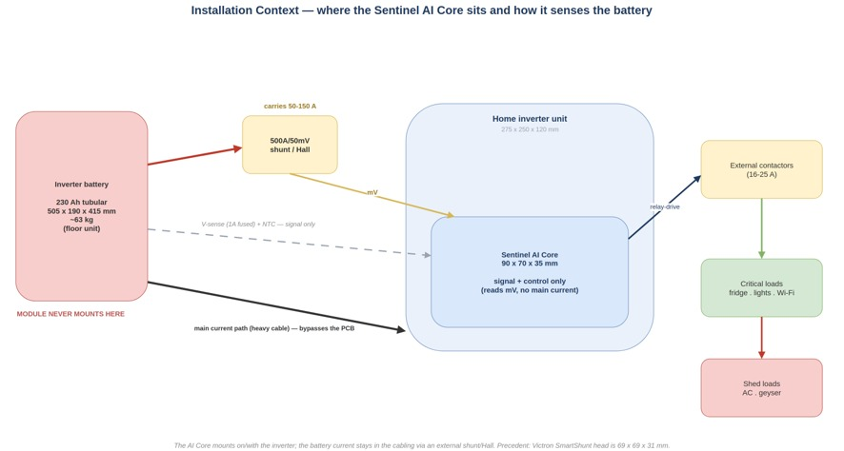
Exhibit 12: Context of installation: The AI Core is mounted along with the inverter and senses the 505 x 190 x 415 mm, ~63 kg battery using an external 500A shunt or Hall effect sensor; all that goes into the PCB is the millivolt signal, while large currents operate contactors externally.
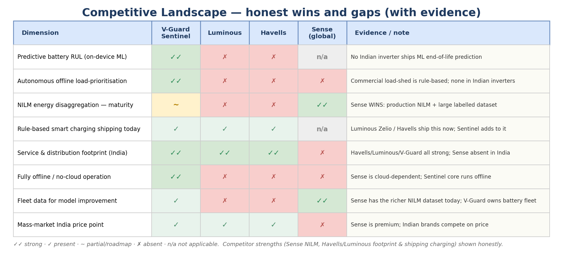
Figure 13. Competitive landscape (with supporting evidence): Real firsts of Sentinel contrasted with competitive capabilities - NILM maturity of Sense and service coverage/charging rules of Havells/Luminous.
14. Business Value and Market Opportunity
The Indian home-UPS market size is estimated at 348 million dollars in 2024, reaching 487 million dollars in 2030, with the inverter-battery market being of the order of 197 million dollars growing at above 6% annually; stabilizers and geysers are additional markets of the magnitude of hundreds of millions of dollars, each growing at mid-single-digit rates [26][27]. V-Guard already serves all these through more than 100,000 retail touchpoints (distribution reach; the compatible installed base is a subset), hence the scope of the upgrade driven by software is vast, and the rollout of smart meters in the country with the implementation of time-of-use tariff is driving demand for energy optimization provided by Sentinel. There are four sources of value for V-Guard. First, warranty and service cost reduction: the warranty cost at V-Guard was around 1.52% of revenue, equivalent to 69 crore rupees in a recent year [25], where only the battery-attributed, avoidable part is addressable, being just a fraction, because a lot of warranty costs are due to manufacturing defects, and the predictive maintenance turns some of the emergency claims into proactive services while preventing avoidable warranty cases such as electrolyte negligence. Second, retention and proprietary data moat which becomes deeper with each device - the hardest asset to replicate. Third, aftermarket capture through a properly timed strategy: even though a weeks-ahead warning does not guarantee that the battery will be bought from V-Guard, since an informed customer can still choose another supplier, the mechanism of capture should be the convenience - a one-click order through app delivered by V-Guard's 100,000 touchpoint repair network with door-to-door exchange and trade-in rebate, thus making a real V-Guard battery the easiest choice, not the cheapest generic. Fourth, portfolio extension, as the computing platform can be used for other devices such as pumps, stabilizers and geysers.
An illustrative example: a small additional Core cost is recouped every time it avoids one unnecessary warranty replacement (lead-acid battery replacement costs thousands of rupees) or successfully captures one well-timed after-market battery at V-Guard's margin - meaning that just a small fraction of the warranty spend is sufficient for positive ROI from the programme. We refrain from fully elaborating a model, but this breakeven analysis stands and does not imply overcharging the consumer.
15. Sustainability and Social Impact
Increasing battery lifespan - temperature-compensated, anti-sulphation charging and deep-discharge mitigation are proven factors [6], increase of the battery's lifespan by about 15-30%, pending field validation - and timely replacement minimizes the prematurely discarded lead-acid batteries - crucial, since, by some estimates, between 60% and 80% of India's lead-acid recycling is informal, and lead poisoning already affects an estimated 275 million Indian children [28]. Reduced energy consumption from optimized charging, extended product life and reduced material demand from predictive maintenance across the portfolio. For price sensitive and rural consumers, self-managing, resilient backup ensures uninterrupted operation of food refrigerators, studying, connecting to internet and using medical devices during outages which still remain an everyday experience [1][2]. This is sustainability not a bonus, but the direct result of building products that predict, optimize and last.
16. Competitive Differentiation
Exhibit 13 shows that none of the popular Indian inverters available on market offer any of machine learning of battery failure prediction, autonomous offline load prioritization and improvement of the model through collected data - those three things make Sentinel novel and deliver it offline at the mass-market cost. Competitors excel in other dimensions: Sense in NILM maturity, Havells and Luminous in the service footprint and rule-based charging respectively - which we acknowledge openly.
17. Risks and Mitigations
Overstatement - mitigated through clear distinction between research and deployment scope of each module and reporting ranges rather than false precision. Generalization of the model across chemistry, climates and individual households is managed with our aging program, federated refinement and household calibration with conservative confidence bounds. Privacy risk is covered with Secure Aggregation and Differential Privacy and reasonable initial claims. Costs are kept in check with the tiered Bill of Materials and reuse of the existing sensors. Safety is handled through isolation of the platform, fail-safe relay behavior (loads default to being powered in case of a fault condition with a watchdog), compliance with standards and validation in the reliability lab.
18. Roadmap and Vision
The process is advanced via milestone gates rather than calendar ones. Gate 1 (dataset acceptance): the aging program in-house has to achieve a target RUL prediction window hit rate on hold-out batteries before any RUL feature is shipped. Gate 2 (field test): battery-RUL prediction and the load-autopilot will be run in the monitored Smart-Pro pilot fleet and validated against real battery replacements. Gate 3 (stability of learning): the training pipeline, central or federated, has to demonstrate stable, non-degrading model updates before the broad deployment. Only after those two, the platform can expand to cover water pumps, stabilizers and water heaters. The idea is that by 2030 the entire product line of V-Guard products in the Indian household will be running on one single AI platform, operating not as separate appliances, but as one coherent system that can predict and prevent its own failures, manage power in the house and ensure uninterrupted operation of essentials through any outage without user's intervention.

Appendix:
Exhibit 14. Key parameters and performance targets
Parameter | Target / range
Battery current sensing | EXTERNAL 500A/50mV (~0.1 mΩ) busbar shunt or ACS758 Hall (±200A); INA226/228 reads mV only — main current never on the PCB; auto-zero offset
Isolated voltage sensing | 150–300 V via divider + reinforced isolation (AMC1311); thin sense leads FUSED 1A at terminal; ±5–10 mV (lead-acid)
Temperature | Battery-terminal NTC; optional ±0.1 °C digital (TMP117); operating 0–55 °C
Enclosure & mounting | ~90 × 70 × 35 mm, PC/ABS UL94 V-0, IP20; mounts on/with the inverter (NOT the battery); high-current loads via external contactors
Compute / model | ESP32-S3 (Xtensa LX7, ESP-DSP/ESP-NN); int8 models 5–100 KB flash + ~8 KB activation RAM; 512 KB on-chip SRAM (RTOS/BLE/Wi-Fi headroom); inference <10 ms
SoC estimation | Coulomb count + OCV + EKF; error budget ±5%
SoH usable threshold | 80% of rated capacity (end-of-life convention)
RUL output | State-of-health with uncertainty band; graded warning 'replace within N weeks'
Load tiers | T1 keep (fridge, lights, Wi-Fi, medical) · T2 defer (geyser, pump) · T3 shed (AC) — for loads actually on the inverter
Power-quality | 1-cycle time-domain RMS (sag/swell events) + multi-cycle FFT (harmonics); 128–256 samples/cycle; IEC 61000-4-30 Class-S-like; detection not prediction
Learning path | Primary: opt-in anonymised fleet telemetry → central training. Optional: federated (gateway/phone) + Secure Aggregation + Differential Privacy (target ε≈4, δ=1e-5 per user-year)
Product targets | Battery-life extension target ~15–30% (pending validation); backup extension ~10–20% where sheddable load exists; low active draw (radio duty-cycled, off during outage)
Compliance | IS/IEC 62368-1; IEC 62040 (host); IEC 61000 EMC; IS 16046-2 (if Li cell); RoHS/CE
Exhibit 15. Illustrative bill of materials (basic variant; premium detailed in hardware notes)
Item (basic variant) | Approx. INR
ESP32-S3 module (Wi-Fi + BLE) | 250
INA226 monitor (reads battery-shunt mV) | 60
NTC battery-terminal temperature | 15
ULN2003 relay-driver (drives external contactors) | 20
Wide-Vin buck (3.3 V) + LDO | 45
UL94 V-0 enclosure | 60
Connectors + 1 A-fused sense leads | 50
Board subtotal (≈) | ~500
External 500 A / 50 mV busbar shunt (reused if inverter has one) | 300
BASIC standalone total (≈) | ~800 (~500 if shunt reused)
Incremental over a metering inverter (shunt/relay/MCU shared) | ~150–300
References
[1] LocalCircles, India Power Outage Survey, 2023.
[2] Council on Energy, Environment and Water (CEEW), India Residential Energy Survey (IRES), 2020.
[3] Prayas (Energy Group), Quality of Electricity Supply in India, 2023.
[4] P. Ruetschi, 'Aging mechanisms and service life of lead-acid batteries,' Journal of Power Sources, 127 (2004) 33-44.
[5] J. Vetter et al., 'Ageing mechanisms in lithium-ion batteries,' Journal of Power Sources, 147 (2005) 269-281.
[6] Battery University, BU-806a: How Heat and Loading Affect Battery Life.
[7] K. A. Severson et al., 'Data-driven prediction of battery cycle life before capacity degradation,' Nature Energy, 4 (2019) 383-391.
[8] NASA Prognostics Center of Excellence (PCoE), Battery Data Set Repository.
[9] CALCE Battery Research Group, University of Maryland, Battery Data.
[10] Sandia National Laboratories cycling dataset, batteryarchive.org.
[11] R. David et al., 'TensorFlow Lite Micro,' arXiv:2010.08678, 2020.
[12] Espressif Systems, ESP-DSP and ESP-NN optimised signal-processing and neural-network libraries for the ESP32-S3 (Xtensa LX7), 2023-2024.
[13] J. Chaoraingern and A. Numsomran, 'Embedded Sensor Data Fusion and TinyML for Real-Time Remaining Useful Life Estimation of UAV Li-Polymer Batteries,' Sensors, 25(12):3810, 2025, doi:10.3390/s25123810.
[14] D. J. Beutel et al., 'Flower: A Friendly Federated Learning Framework,' arXiv:2007.14390, 2020.
[15] K. Bonawitz et al., 'Practical Secure Aggregation for Privacy-Preserving Machine Learning,' ACM CCS, 2017.
[16] Google Research, 'Federated Learning with Formal Differential Privacy Guarantees (DP-FTRL),' 2022; arXiv:2305.18465.
[17] J. Lin et al., 'On-Device Training Under 256KB Memory (MCUNetV3),' NeurIPS, 2022; arXiv:2206.15472.
[18] IEC 61000-4-30, Testing and measurement techniques - Power quality measurement methods.
[19] IEEE Std 1159, Recommended Practice for Monitoring Electric Power Quality.
[20] C. Zhang et al., 'Sequence-to-point learning for non-intrusive load monitoring,' AAAI, 2018.
[21] N. Batra et al., iAWE: India Appliance-level energy dataset.
[22] IS/IEC 62368-1:2023, Audio/video, information and communication technology equipment - Safety.
[23] IEC 62040, Uninterruptible power systems (UPS).
[24] IS 16046-2 / IEC 62133-2, Secondary lithium cells and batteries - Safety.
[25] V-Guard Industries Ltd, FY2026 Financial Results and investor communications.
[26] MarketsandMarkets, India Home UPS / Inverter Market report.
[27] IMARC Group, India Inverter Battery Market report.
[28] Pure Earth, India Lead Exposure / Global Lead Program.
[29] Ministry of Power, Revamped Distribution Sector Scheme (RDSS) smart-metering status, 2025-26.
[30] Texas Instruments INA228, AMC1311, TMCS1100; Espressif ESP32-S3 datasheets.
[31] Tesla Powerwall and smart-panel product documentation (essential-load prioritisation).
[32] Victron Energy SmartShunt / BMV-712 battery-monitor documentation (500A/50mV shunt architecture); Allegro ACS758 Hall current-sensor datasheet.

